Pay it Forward Outreach
Wellness Village 11th Annual Giving Tree
Please grab an ornament on the tree for ideas or just bring in non parishable food. All donations need to be dropped off here by December 29th.

Don’t have time to shop?
You can contributing cash or write a check to : Pay it Forward Outreach
This money will help pay for storage center where donations are collected, food and other items the shelters request.
The organizations and people that will benefit from the Giving Tree donations.
- Shepherds Way Relief Center- Stocks the pantry that is given to the homeless
- VA Home for Boys & Girls for the kids’ “Back Packs of Food” for the weekends
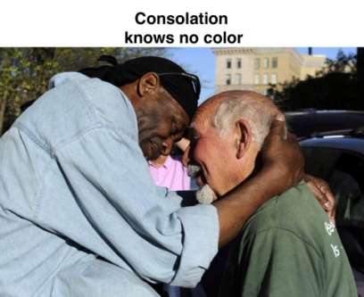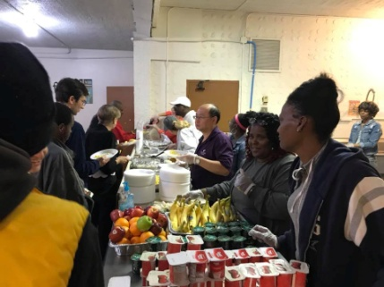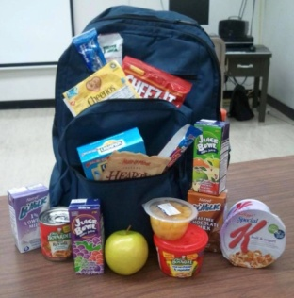
- The homeless living on the streets of downtown Richmond
- Those coming out of homelessness and starting lives over

Thank you as always for your support and contributions.

